Solution using Swap

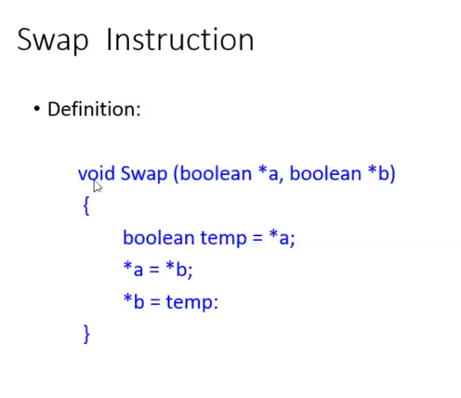



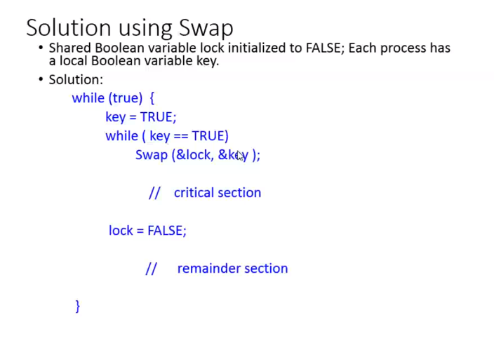



lock 🡪 False  
key 🡪 True



P1 coming inside  
 while(True)  
 key = True  
 while(key==True)  
 { Swap(&lock,&key) }  
 Critical section   
While checking once again, while loop breaks and P1 enters the critical section.



lock = False



This is the point where P1 releases the lock



When P1 is in the critical section   
At the same time when P2 enters what happens????  
Since the P2’s key=true



while(key==True)  
 { Swap(&lock,&key) }



This while loop keeps on looping unless P1 release its lock(i.e lock=False)

Swap should not be pre-empted in-between



Which ever process is in critical section that process holds the lock   
If P1 is in CS P1’s lock 🡪 true. Unless P1 releases its lock (i.e lock=False) P2 can’t go into the critical section.

